## The Signs Palette

The sign palette is the repository for each of the signs in RapidPlan. Aside from the signs themselves, the signs palette has three main components:

* The Sign Library
* The Sign Categories
* Search Signs
* 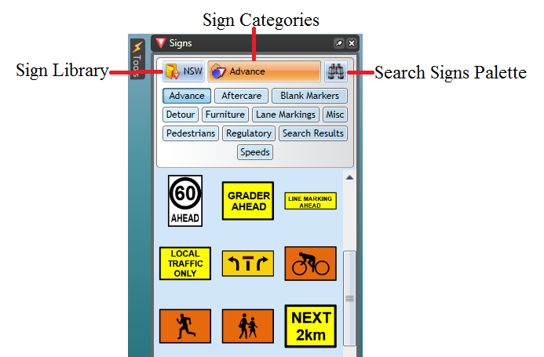
* Signs_Palette

## Sign Library

This drop down control allows you to select which signage pack you wish to use. In some cases you will only have one pack installed, but certain countries will have numerous state/region packs also installed. Changing the sign pack often changes sign tab options.

## Sign Categories

The signs are organized into tabs so that they are easy to find. Clicking through the tabs will reveal the signs for each category. You can view and example of the categories in the image below.



signs palette

## Search Signs

New version of RapidPlan allows you to search entire signs library by a keyword, phrase, sign name or sign code. For example, if you were looking for a **STOP** sign, you can search it by name **stop** or by code **R1-1**.

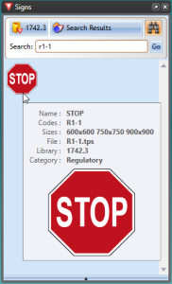

Sign_search

**Note:** R1-1 is code for STOP sign in Australia, other countries codes may vary